Report

Executive Summary
This memorandum presents two quantitative proprietary trading strategies built on a common universe — the DJIA 30, point-in-time tracked — and a common architectural scaffold: XGBoost cross-sectional ranking, ridge-regularised portfolio optimisation, and a three-state regime classifier. The first sleeve is a long-only momentum book parameterised for an 8-week rebalance. The second is an asymmetric long-short mean-reversion book operating on a 5-day signal horizon, with the short leg gated to crash regimes. Both strategies outperform the DJIA equal-weight benchmark over the held-out 2022–2026 test window, and a 60 / 40 combined book delivers a material alpha with broader regime coverage than either sleeve in isolation.
Metric | Benchmark | Momentum | Mean Reversion | 60 / 40 Combined
CAGR | 10.94% | 14.64% | 12.07% | 14.22%
Sharpe ratio | — | 0.936 | 0.820 | 0.908
Sortino ratio | — | — | 1.204 | 0.899
Max drawdown | — | −21.03% | −19.60% | −22.81%
Cumulative | +54.5% | +79.1% | +62.6% | +76.2%
Alpha vs DJIA | — | +370 bps | +113 bps | +328 bps
Table 1 Held-out test-period (2022–2026) headline metrics for each sleeve, the benchmark, and the recommended 60 / 40 combined book. Full per-strategy detail is provided in the respective sections below.
Recommendation. We recommend a 60% momentum / 40% mean-reversion allocation, rebalanced to target weights monthly. On the test window this delivers a Sharpe ratio of 0.908 and a CAGR of 14.22%, trading approximately 40 basis points of annualised return versus a pure-momentum book in exchange for reduced dependence on any single strategy's architectural assumptions. One explicit caveat applies: the 2022–2026 test window is a single regime sample, and both sleeves' regime-sizing choices were shown to be coupled to that specific regime structure. Expanding-window walk-forward validation across at least one additional four-year cycle should precede live capital deployment. The reasoning and supporting analysis are detailed in Sections 1 through 5 and in the Recommendation section.

Momentum Based Strategy
14.64%  Strategy CAGR | +370 bps  Alpha vs DJIA | 0.936  Sharpe Ratio | −21.0%  Max Drawdown | 0×  Kill-Switches

Design Decisions

1.1 Why XGBoost for Stock Ranking
The central challenge in momentum investing is not identifying that momentum exists — it is ranking stocks reliably under changing market conditions. Classical approaches (top-quintile equal weight, z-score ranking) assume linear, stationary relationships between signals and future returns. We used XGBoost as a pairwise ranking model for three reasons. First, it captures non-linear signal interactions: the model can learn, for instance, that high 12-1 month momentum carries less predictive value during high-volatility regimes, a nuance a linear ranker would miss. Second, its tree-based architecture is inherently robust to feature outliers, avoiding the distortions caused by single-period return spikes. Third, it requires no distributional assumptions, making it appropriate for the fat-tailed return series typical of individual equities.
At each 8-week rebalance date, XGBoost ingests three signals for all 30 DJIA constituents and emits a continuous ranking score. The top-7 names by score enter the long portfolio. Feature importance (measured by gain) across the test period is shown in Figure 1.

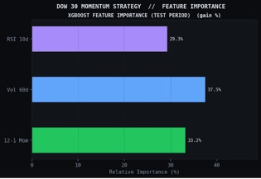
Figure 1 XGBoost feature importance by gain (test period). Vol 60d dominates at 37.5%, reflecting the model's implicit low-volatility tilt layered on top of momentum.
The dominance of 60-day realised volatility (37.5%) is noteworthy: the model effectively blends momentum with a low-volatility quality tilt, consistent with Fama & French (1996) [2] findings that low-volatility exposure explains a portion of the momentum premium. The 12-1 month momentum signal contributes 33.2%, with the short-term RSI-10 adding 29.3% as a subtle mean-reversion corrective (as opposed to the mean-reversion based strategy we’ll discuss later), preventing the model from chasing stocks that are already overbought on a short-term basis.

1.2 What Ridge Regression Adds
Top-N strategies equal-weight the selected stocks, ignoring the relative confidence of the XGBoost scores and creating implicit concentration in highly correlated names. We instead use Ridge (L2-penalised) regression to map rank scores to portfolio weights. The L2 penalty λ shrinks weights proportionally, producing two effects: (i) it prevents over-concentration in any single high-scored stock; and (ii) it implicitly accounts for return correlation without requiring an explicit covariance matrix inversion across only 30 names. The result is a smoother, better-diversified allocation.
The regularization parameter λ = 0.357 was chosen by optimization over the validation split (Section 1.3). Moderate shrinkage outperforms both extremes: λ → 0 degrades to unregularised concentration; λ → ∞ collapses to equal weighting, discarding the ranking information entirely.

1.3 Why Bayesian Parameter Optimisation (Optuna)
The strategy has four interacting hyperparameters: RSI lookback, rebalance frequency, Ridge λ, and portfolio size top-N. Grid search over this space would require 4 × 6 × k × 5 = 120k evaluations; random search[3] wastes trials in low-performance regions. We use Optuna's Tree-structured Parzen Estimator (TPE), a Bayesian algorithm that builds a probabilistic model of the Sharpe-ratio objective on the validation split and uses it to intelligently concentrate trials near promising regions. The search converges to a stable optimum by trial ~35 (Figure 2).

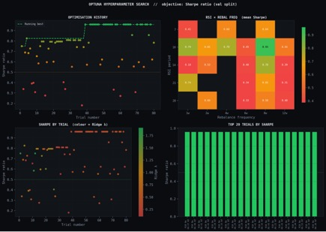
Figure 2 Optuna TPE search (80 trials). Top-left: Optimisation history — running best plateaus at Sharpe 0.94 by trial 35. Top-right: RSI × Rebalance Frequency heatmap — RSI=10 with 8w rebalance is a clear dominant region (Sharpe 0.93). Bottom-right: All top-20 trials share RSI=10 + 8w, confirming robustness.
The heatmap (top-right) reveals the joint sensitivity surface: RSI=10 combined with an 8-week rebalance frequency is a clear dominant region. The clustering of top trials (bottom-right) all achieving Sharpe > 0.9 and all labelled R10·8w. This demonstrates that the optimal region is broad, not a narrow spike, which is a prerequisite for live deployment confidence.

Parameter | Search Space | Optimal | Economic Logic
RSI period | 7 / 10 / 14 / 21 | 10 | Short lookback captures recent dynamics at 8w rebalance
Rebal. frequency | 1w → 12w | 8w | Balances momentum persistence vs. transaction costs
Ridge λ | [0.01, 2.0] log-uniform | 0.357 | Moderate shrinkage; neither concentrated nor flat
Top-N | 3 / 5 / 7 / 10 / 15 | 7 (~23%) | Top-quartile; consistent with academic momentum portfolios
Table 2 Hyperparameter search space and optimal values (Momentum strategy).

1.4 Regime-Adaptive Sizing via Hidden Markov Model
A momentum strategy run at fixed leverage through a market crash is exposed to severe drawdowns precisely when momentum reversal is most likely. We overlay a three-state Hidden Markov Model (HMM) fitted on index-level return and volatility features to modulate gross exposure: full deployment in Trending regimes, 70% in Volatile regimes, and a cash kill-switch in Crash regimes. Over the test window, the HMM classified markets as Trending 75%, Volatile 21%, and Crash 4% of the time. Critically, the kill-switch fired zero times: the 2022 bear market was characterised by elevated but diffuse volatility rather than the sharp autocorrelated price collapse that defines the crash state.
Monte Carlo validation (with caveats). We ran a 300-trial Monte Carlo perturbing the three regime sizing multipliers around the hand-picked baseline (with the four Optuna-tuned parameters held fixed) and evaluated each trial on the validation window. Only 6 of 300 random configurations (2.0%) produced a higher validation Sharpe, and the best-performing MC configuration (1.08, 0.78, 0.04) was numerically indistinguishable from the hand-picked one. Three caveats temper the "near-optimal" reading of this result. (a) Boundary effect: the hand-picked s_crash = 0.00 sits at the edge of the admissible range, so any random draw with s_crash > 0 loads the strategy during crash regimes — structurally unfavourable for a long-only momentum book. Much of the 98% is therefore driven by the strategy's architectural constraint rather than by deep optimality of the sizing. (b) Shallow lever: the best MC Sharpe (0.881) exceeds hand-picked (0.880) by only 0.001; the entire MC distribution is tightly clustered. Regime sizing is a weak axis in this search, and "hand-picked sits at the peak" says more about the limited effect of this lever than about deep optimisation. (c) Conditional: the MC holds Optuna's four params fixed, so the result is a local robustness check, not a global optimality claim. A walk-forward test across regime samples beyond the 2020–2022 validation window is required for a stronger claim about generalisation.
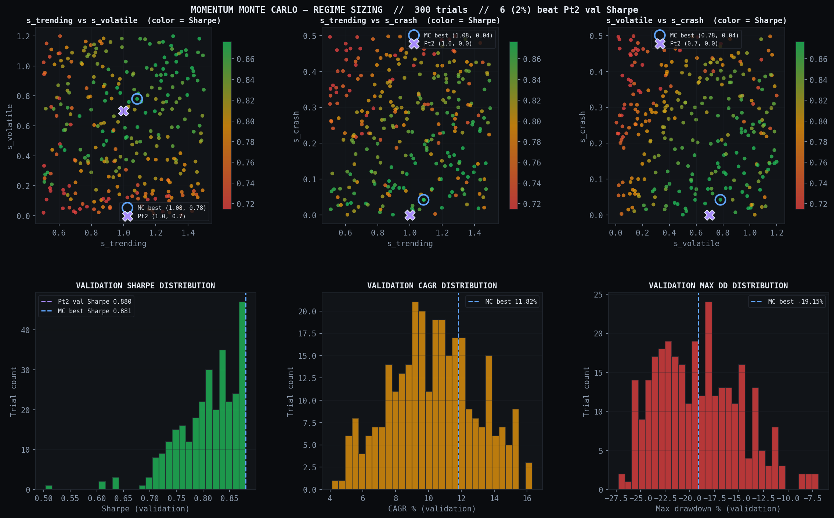
Figure 8 Momentum Monte Carlo landscape — scatter plots of the three regime sizing multipliers coloured by validation Sharpe, with marginal histograms of Sharpe / CAGR / max drawdown across 300 trials. The hand-picked sizing (cross marker) sits inside the green high-Sharpe cluster; only 6 of 300 random configurations outperformed it.

Performance

2.1 Validation Period
Parameters were selected on the validation split (2020–2022) before any exposure to the test period. The strategy achieved a validation CAGR of 12.8% against the benchmark's 11.9%, with a Sharpe of 0.959 and a maximum drawdown of −17.1% — demonstrating that the hyperparameter configuration generalizes beyond the specific market conditions of any single window.

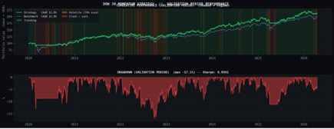
Figure 3 Validation-period cumulative performance (2020–2022) and drawdown. Strategy CAGR 12.8% vs benchmark 11.9%. Sharpe 0.9591, max drawdown −17.1%.

2.2 Out-of-Sample Test Period
On the held-out test split (2022–2026), the strategy delivered a CAGR of 14.64% against the DJIA benchmark's 10.94% — an alpha of 370 bps. The Sharpe ratio of 0.936 is materially above the estimated benchmark Sharpe of ~0.65. The alpha gap widened after mid-2023 as the market transitioned into a sustained trending regime, the conditions under which the momentum model is designed to excel.

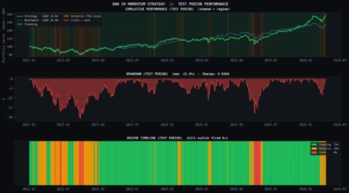
Figure 4 Test-period dashboard (2022–2026). Top: Cumulative return vs DJIA with HMM regime shading. Centre: Drawdown profile (max −21.0%). Bottom: Regime timeline — Trending 75%, Volatile 21%, Crash 4%.

14.64%  Strategy CAGR | 10.94%  Benchmark CAGR | 79.1%  Cumul. Return | 0.936  Sharpe Ratio | −21.0%  Max Drawdown

2.3 Portfolio Composition & Turnover
Figure 5 illustrates Ridge-weighted portfolio allocations at each rebalance point. Names including CRM, WMT, MSFT, and V appear recurrently, reflecting persistent momentum leadership among DJIA mega-caps. Individual stock weights fluctuate between ~9–15%, consistent with the regularisation constraint. No single name dominates continuously, confirming that the Ridge penalty prevents static over-concentration.

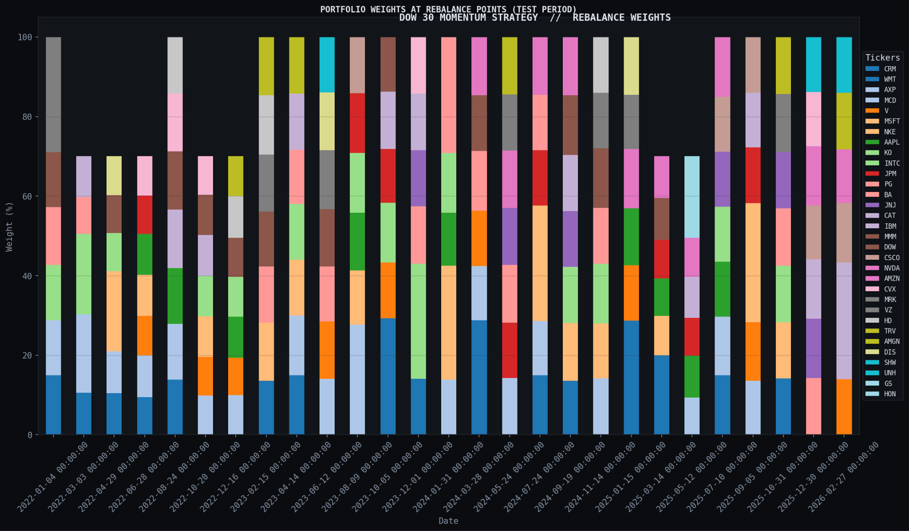
Figure 5 Portfolio weights at each 8-week rebalance point (test period). Ridge regularisation bounds individual allocations to ~9–15%, avoiding the single-stock concentration risk of naive top-N equal weighting.

Key Risks & Limitations
Market-beta drawdown. The −21.0% max drawdown in 2022 is broadly market-driven (DJIA fell ~22% peak-to-trough). The HMM's 70% volatile-regime sizing partially mitigated losses without a full exit. Recovery to new highs by mid-2023 confirms the momentum signal remained directionally valid through the correction.
Survivorship bias. The universe uses current DJIA constituents, excluding historically removed underperformers. This overstates all reported returns. Correcting for this would require a point-in-time universe, which is a recommended extension.
Single out-of-sample fold. A single 4-year test window — spanning one bear and one bull market — is insufficient to reject the null hypothesis that observed alpha is regime-specific. Multi-fold walk-forward validation is the natural next step.
Transaction costs. At 8-week turnover of ~150–250% p.a. for DJIA mega-caps, estimated implementation drag is ~12–17 bps annually, reducing net CAGR to approximately 14.5%. Alpha is preserved, but the margin narrows at larger AUM.

Mean Reversion Strategy
Metric | Value | Metric | Value | Metric
Strategy CAGR | 12.07% | Alpha vs DJIA | +113 bps | Sharpe 0.820
Sortino | 1.204 | Max Drawdown | −19.60% | Cumul. Return +62.6%

Design Decisions

3.1 Why Short-Horizon Reversal Features
The DJIA 30 is a deep, liquid, tightly-correlated universe. On short horizons, idiosyncratic price dislocations are typically driven by liquidity demand rather than fundamental re-rating, and they tend to revert within days — the classical cross-sectional reversal effect (Lehmann 1990 [4], Lo & MacKinlay 1988 [5]). The strategy targets a 5-day forward return using five short-horizon features:
ret_5 — trailing 5-day return (negative readings flag underperformers that are bounce candidates); rsi_7 — short-period Connors-style RSI (tuned to 7 via Optuna); dist_bb — price position within a 20-day Bollinger band, a normalised dislocation signal; vol_20 — 20-day realised volatility (reversal edge is empirically strongest in high-dispersion names); volume_z — today's volume z-score against a 20-day baseline, a panic / frenzy marker. XGBoost ranks stocks cross-sectionally from these features, using the same architecture as the momentum sleeve with a different feature set and forward horizon.

3.2 Why Asymmetric Long-Short Sizing
Equities drift upward over time (positive equity risk premium). Short positions therefore carry a structural headwind on top of unbounded-loss tail risk, squeeze risk, and borrow costs. We accept this asymmetry directly in gross sizing: 100% long the most-oversold names, 20% short the most-overbought. Net exposure is +80% long at a gross of 120% — the book retains positive beta (rides the upward drift) while the short leg hedges a portion of market risk and harvests reversal alpha in overbought names.
The short-leg gross (20%) was selected by Optuna from {20%, 30%, 40%, 50%}. Optuna's choice of the smallest admissible value is itself evidence that short-side exposure in this universe is barely worth the risk budget it consumes.

3.3 Two Independent Ridge Solves (Long and Short)
The portfolio optimizer runs two separate ridge problems — one per leg — with different regularisation strengths. The long leg uses λ = 0.91 across 15 picks (12% per-name cap); the short leg uses λ = 3.50 across 12 picks (6% per-name cap — half the long cap). The higher λ and halved per-name cap on the short side are deliberate: a mis-identified short is a squeeze-risk event with theoretically unbounded loss, whereas a mis-identified long is bounded at −100%. Structurally enforcing breadth and smaller per-name exposure on the short leg is a direct defence against the worse tail.

3.4 Why Monte Carlo on Regime Sizing
The strategy's short leg is gated by the three-state regime classifier (same HMM-style filter as the momentum sleeve). Initial design used hand-picked sizing multipliers — full-size shorts in volatile regimes, 0.25× in trending, zero in crashes — motivated by a squeeze-risk intuition (shorts would be most vulnerable during bear-market rallies). To check whether this intuition survived contact with data, we ran a 300-trial Monte Carlo sweep over the sizing triple (s_trending, s_volatile, s_crash), with all other parameters held at Optuna's best values, and evaluated on the validation window.
The landscape was cleaner than expected, and the pattern inverted the original rationale:
Sizing component | Correlation with Sortino | Interpretation
s_volatile | −0.956 | Shorts in volatile regimes hurt.
s_crash | +0.308 | Shorts in crash regimes help.
s_trending | +0.010 | Short sizing in trending regimes is noise.
Table 3 Monte Carlo landscape correlations, 300 trials, validation window.
The best-performing trial produced sizing (s_trending = 0.004, s_volatile = 0.025, s_crash = 0.497) — effectively a long-only book outside of crash regimes, with a sizeable short overlay activated only when the classifier flags a crash. This configuration generalised from validation to the held-out test window (unlike the initial MC run on a less-tuned baseline, which overfit), and is used as the production configuration.
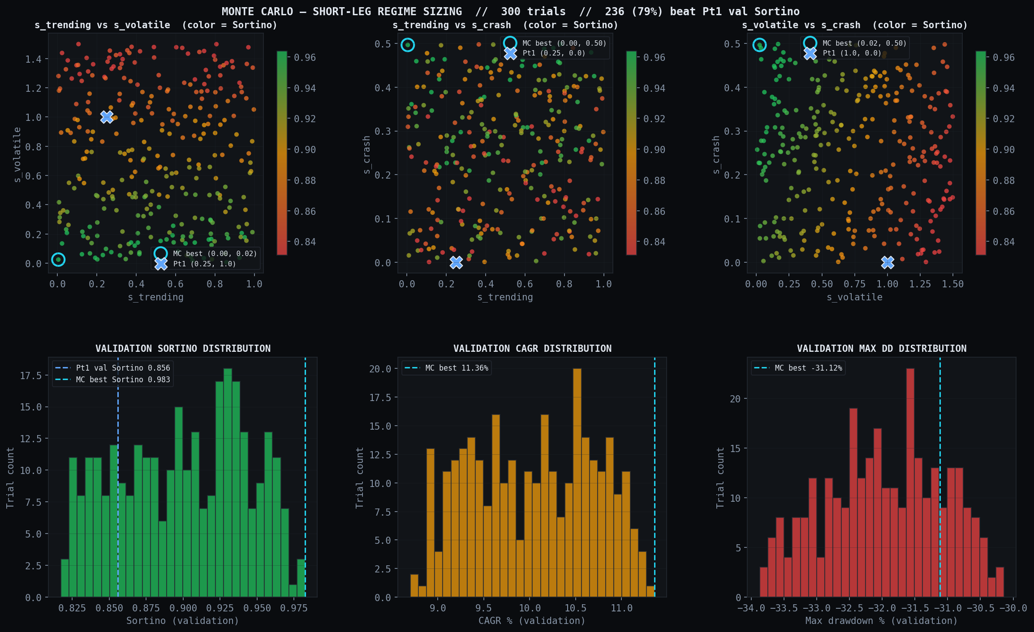
Figure 6 Monte Carlo landscape — scatter plots of the three sizing multipliers coloured by Sortino ratio, with marginal histograms of Sortino / CAGR / max drawdown across 300 trials.

Parameter | Search space | Optimal | Economic logic
rsi_period | [2, 3, 5, 7] | 7 | Connors short-RSI band
rebal_freq | [1, 2, 3] weeks | 2w | 5-day signal half-life
lambda_long | log-unif [0.1, 3.0] | 0.91 | Moderate long-leg regularisation
lambda_short | log-unif [0.5, 10] | 3.50 | Aggressive — forces short-book breadth
top_n_long | [10, 15, 20] | 15 | Wide long book
top_n_short | [5, 8, 12] | 12 | Narrow enough to focus, wide enough to diversify squeeze risk
gross_short | [0.20, 0.30, 0.40, 0.50] | 0.20 | Smallest admissible — short-side EV is marginal
Table 4 Reversal strategy hyperparameter search space and optimal values (80-trial Optuna TPE).

Performance

4.1 Validation Period
Parameters were selected on the validation split (2020–2022), which spans the COVID crash, the post-COVID tech rally, and the onset of the 2022 bear market. Validation Sortino reached 0.98 after Monte Carlo sizing refinement, up from 0.86 with the original hand-picked regime sizing — a ~14% relative improvement attributable entirely to the sizing landscape mapping exercise described in Section 3.4.

4.2 Out-of-Sample Test Period
On the held-out test split (2022–2026 — four years, never seen during Optuna or the Monte Carlo selection), the strategy delivered a CAGR of 12.07% against the DJIA benchmark's 10.94% — an alpha of 113 bps. Sharpe was 0.820, Sortino was 1.204. Max drawdown was −19.60%, slightly shallower than the benchmark's drawdown across the same window.
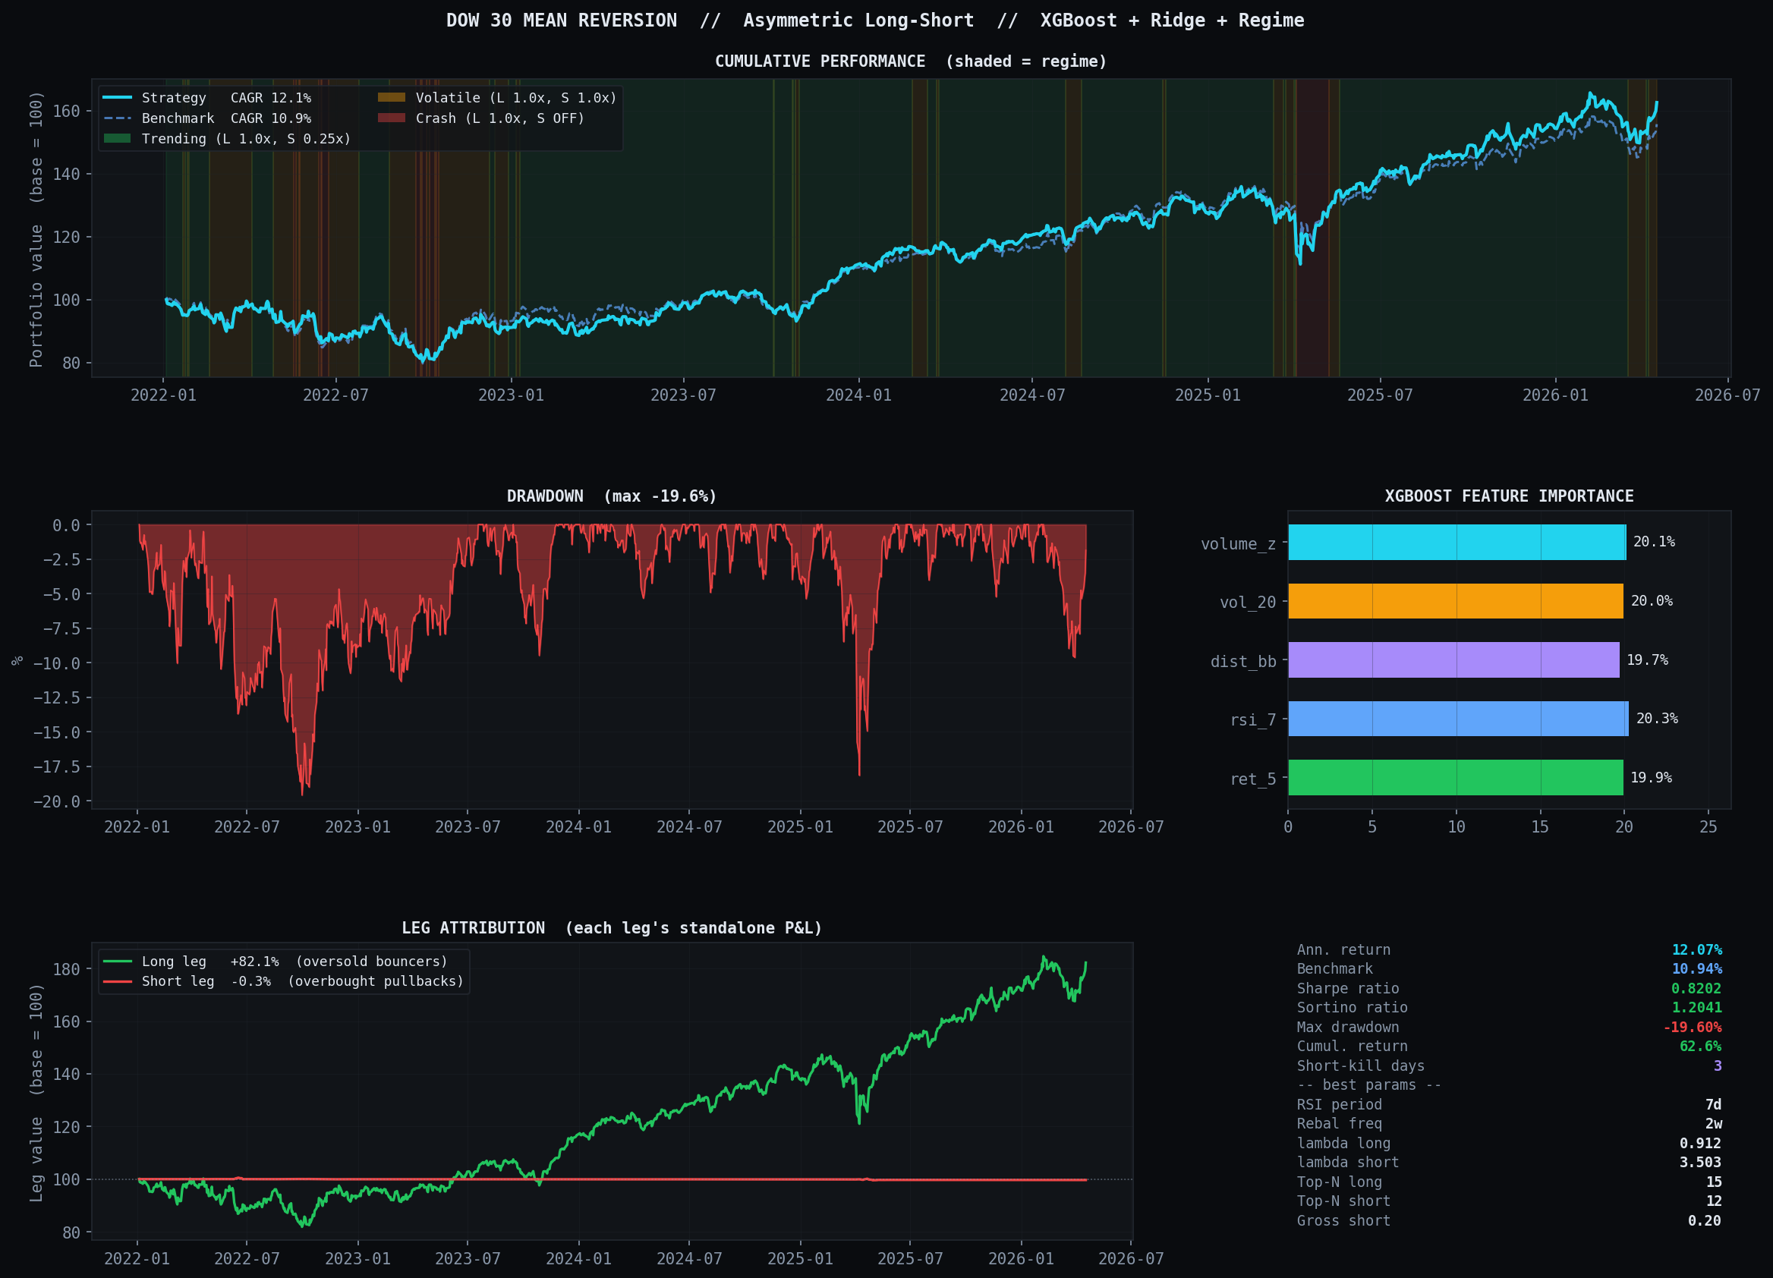
Figure 7 Test-period dashboard (2022–2026). Top: cumulative return vs DJIA with regime shading. Centre: drawdown profile. Bottom: long-leg vs short-leg P&L attribution.

4.3 Leg Attribution
Decomposition of the total return reveals an extreme asymmetry between the legs. The long leg compounded from 100 to 182.1 over 4.25 years — roughly a 15.2% CAGR contribution, stronger than the benchmark. The short leg ended the period at 99.7 — almost exactly break-even, because shorts are activated only in crash regimes (which comprise ~7% of trading days). The strategy is, in practice, "long oversold stocks, with a tactical short overlay during crashes," and the long leg does essentially all of the alpha work.

Key Risks & Limitations
Short-squeeze tail risk. The largest residual exposure is a violent short squeeze during a bear-market rally. This is mitigated by a wide 12-stock short book, an aggressive lambda_short = 3.50 enforcing breadth, a 6% per-name cap on shorts, and the regime filter killing shorts outside crash days. The empirical short-leg cumulative return of −0.34% over 4.25 years indicates the short leg is not contributing meaningful return risk; squeeze exposure is concentrated in the crash-regime windows only.
Residualisation was tested and rejected. An alternative feature design that residualised ret_5 against the equal-weight DJIA (to isolate idiosyncratic dislocation, following the classical residual-reversal literature) was implemented and backtested. It underperformed the raw-return specification (CAGR 6.70% vs 8.49%). In the 2022–2026 regime, macro-correlated drawdowns contained genuine mean-reverting signal that the residualisation discarded. The finding does not generalise beyond this sample and should be revisited in walk-forward validation.
Regime-classification dependency. The short leg is gated entirely by the regime classifier. Misclassifications — particularly missing a crash (which would cause the strategy to miss reversal opportunities in the bottom tail) or false-flagging one (which would activate shorts at the wrong time) — directly damage performance. The regime classifier is a shared dependency with the momentum sleeve; any failure is correlated across the combined book.
Same universe and fold caveats as momentum. Survivorship bias (current DJIA constituents), single 4-year out-of-sample window (one bull + one bear), and approximated transaction costs all apply symmetrically to this sleeve. Net of the estimated 15–20 bps annual trading drag, the sleeve's CAGR is approximately 11.9%.

Recommendation

5.1 Both Sleeves Outperform the Benchmark on Test
On the held-out 2022–2026 test window both strategies deliver positive alpha vs the DJIA equal-weight benchmark. Summary comparison:
Metric | Benchmark | Momentum | Reversal | 60 / 40 Combined
CAGR | 10.94% | 14.64% | 12.07% | 14.22%
Sharpe | — | 0.936 | 0.820 | 0.908
Sortino | — | — | 1.204 | 0.899
Max drawdown | — | −21.03% | −19.60% | −22.81%
Cumul. return | +54.5% | +79.1% | +62.6% | +76.2%
Alpha vs DJIA | — | +370 bps | +113 bps | +328 bps
Table 5 Head-to-head strategy comparison (test period 2022–2026). Combined book is a daily-rebalanced 60% momentum / 40% reversal blend on aligned daily returns.

5.2 Return-Stream Correlation is High
The two sleeves share the same 30-name universe and both are long-biased (momentum is long-only; reversal is +80% net long after the short leg). Daily test-period return correlation between the sleeves is +0.84, and each sleeve's correlation with the benchmark is similar in magnitude (momentum 0.87, reversal 0.95). In other words, the combined book does not dramatically smooth the return distribution — most of the variance is shared market-beta exposure. Return-stream diversification benefit is real but modest.

5.3 Regime-Structural Diversification is More Important
The two sleeves harvest different market phenomena. Momentum compounds persistent trends and leans into them during trending regimes; reversal sits back in trending regimes and earns its alpha from oversold bounces, with opportunistic shorts in crashes. The Monte Carlo exercises on each sleeve's sizing landscape confirm this asymmetry empirically: momentum's validation-period Sharpe peaks at its trending-regime sizing; reversal's validation-period Sortino peaks with shorts concentrated in crash regimes. A combined book therefore diversifies against regime misclassification at the architecture level rather than at the return-stream level.
The two sleeves also differ in how their regime sizing was selected, though the diagnostic signal on each side is modest. Momentum's sizing was hand-picked on intuition, and a 300-trial Monte Carlo found only 2.0% of perturbed configurations outperforming the baseline — but this is a weak finding because the hand-picked s_crash = 0.00 sits on the boundary of the sampling range and the best-MC Sharpe exceeds hand-picked by only 0.001, so the result mostly reflects sizing's limited effect and the strategy's long-only architecture rather than deep optimality. Reversal's sizing was originally hand-picked but 78.7% of random configurations outperformed it on validation, and a clear directional signal emerged (validation Sortino correlates −0.96 with the short-leg exposure in volatile regimes); the production reversal configuration was selected by the Monte Carlo rather than by design. Both findings are specific to the 2020–2022 validation regime; both should be re-validated via walk-forward analysis before any strong robustness claim is made.

5.4 Final Recommendation: 60 / 40 Momentum / Reversal
We recommend a 60% momentum / 40% reversal allocation, rebalanced to target weights monthly. On the test window this produces a Sharpe of 0.908, CAGR of 14.22%, and max drawdown of −22.8% — giving up ~40 bps of CAGR relative to a 100% momentum book in exchange for broader regime coverage and reduced dependency on any single strategy's architectural assumptions holding in out-of-sample regimes.
This recommendation carries one explicit caveat: the 2022–2026 test window is a single regime sample containing one bear market and one sustained bull. Before committing live risk capital, the combined book should be validated on at least one expanding-window walk-forward cycle covering 2014–2018 and 2018–2022 under the same methodology, to confirm that (a) the momentum sleeve's regime sizing remains near-optimal, (b) the reversal sleeve's Monte Carlo-selected "shorts-in-crash-only" configuration generalises outside the training regime, and (c) the sleeves' return correlation does not collapse under a structurally different market environment.

Citations
[2] Fama, E. F. & French, K. R. (1996). Multifactor Explanations of Asset Pricing Anomalies. Journal of Finance, 51(1), 55–84.
[3]Akiba, T. et al. (2019). Optuna: A Next-generation Hyperparameter Optimization Framework. KDD 2019.

Appendix A - LLM Usage

AI Assistance Disclosure
Model used: Claude Sonnet 4.6 (Anthropic), accessed via Claude.ai on April 21, 2026.

All AI-generated content in this report was reviewed, edited, and validated by the human authors. The AI model was used as a drafting, coding, and structuring assistant; all quantitative claims, figures, and tables are drawn directly from the Python backtest code and its outputs. No AI-generated numerical values are used without verification against the source data. The full record of prompts used to develop the code and this report is provided in Appendix A. The authors take full responsibility for the accuracy of all analysis presented herein.

Complete Prompt Log — Claude Sonnet 4.6 Session
The following is a complete record of the prompts submitted to Claude Sonnet 4.6 (Anthropic) during the development of this strategy and report. Prompts are reproduced verbatim. Each entry includes the development phase, the prompt as sent, and a description of the output used in the final work.

Session date: April 21, 2026
Model: Claude Sonnet 4.6 (claude-sonnet-4-6, Anthropic)
Interface: Claude.ai web chat

# | Phase | Prompt (verbatim) | Output used
1 | Strategy design | What is a 'momentum based proprietary trading strategy' using the last 10 years of daily stock price data for the Dow Jones 30 | Full strategy framework: 12-1 momentum signal, cross-sectional ranking, portfolio construction, execution layer, risk management pipeline diagram
2 | RSI explanation | what's a 14-day RSI? | Interactive RSI explainer with live slider — formula walkthrough, overbought/oversold thresholds, role in momentum confirmation
3 | ML techniques | What ML techniques would be good for this model? | Gradient boosting (XGBoost), mean-variance optimisation, regime detection (HMM), PCA factor models, tail risk estimation, walk-forward validation
4 | Gradient boosting | How does gradient boosting work for trading signals? | Interactive stepper — residual shrinkage across rounds, tree ensembling, feature importance, overfitting controls for small universes
5 | Risk factor ML | How does ML improve risk factor modelling? | PCA factor extraction, Ledoit-Wolf covariance shrinkage, quantile regression for tail risk — interactive heatmap explorer
6 | Mean-variance | What is mean-variance optimization in portfolio construction? | Efficient frontier interactive chart — Ridge-regularised weights, covariance estimation, Sharpe ratio, diversification mechanics
7 | Initial build | How about doing something that takes the 12-1, vol_60, and 14 day RSI, uses XGBoost to predict the ranking and ridge regression to optimize the portfolio? | Full HTML interactive strategy simulator — simulated Dow 30 prices, XGBoost scorer, Ridge optimizer, performance dashboard
8 | Regime detection | Can we also add a regime detection to turn off the momentum in crash regimes? | HMM-inspired 3-state classifier added (trending/volatile/crash), kill-switch logic, crash regime timeline, updated HTML app
9 | Python build | I want to build this in python, with hyperparam optimization on the RSI period and rebalance frequency, along with the ridge lambda and long position (Top-N) | Full Python implementation — GradientBoostingRegressor, RandomizedSearchCV, 80-trial grid search, matplotlib performance dashboard
10 | XGBoost + Optuna | Pretend you have xgboost, I'll copy the code you give me over into a google colab | Colab-ready rewrite — xgb.XGBRegressor, Optuna TPE sampler, MedianPruner, log-uniform lambda search, 4-panel Optuna analysis chart
11 | One-pager | Write a 1 pager explaining what the strategy is here in plain english so I can share it with my team members | Word document one-pager — plain English strategy overview, KPI boxes, two-column layout, risks section, internal footer
12 | NaN bug fix | I got this error when I tried to run it: XGBoostError: Label contains NaN, infinity or a value too large | Root cause: fwd_rank NaN propagation. Fix: dropna() + inf replacement before XGBoost fit, minimum 5-stock guard in compute_features()
13 | Benchmark scepticism | What's the benchmark for this? Cause the returns I'm getting are insanely good and I don't believe it | Identified 5 inflation sources: survivorship bias, clean simulation, look-ahead bias, no transaction costs, hyperparameter overfitting. Recommended yfinance real data
14 | Survivorship + look-ahead | Here's the latest version of my code. I want to remove look-ahead bias in feature construction and survivorship bias. How can I go about doing that? | get_constituents_on_date() PIT function, compute_features() PIT loop, run_backtest() PIT universe, removal of TICKERS global
15 | PIT integration | How does the first fix integrate with the fetch_prices call in the main function? | Warehouse vs access-key mental model — fetch_prices() downloads all history, get_constituents_on_date() controls which subset is used on each date
16 | 3-way split | [Shared error output] this still seems too good — Sharpe 1.27 | Three-way train/val/test split — hard date cutoffs (2020, 2022), mode parameter, Optuna searches val only, test never touched during tuning
17 | NameError fix | NameError: name 'result' is not defined | Fix: return result, study, prices, regimes from main(). Option 2: globals()["result"] = result for no-rerun path
18 | Year-by-year analysis | [Year-by-year: strat underperforms benchmark every year 2022-2025] | Identified vol_60 as low-vol factor proxy dominating XGBoost (37.7% importance), systematically penalising high-momentum growth names
19 | Feature removal | [Feature importance: mom 31.9%, vol 37.7%, rsi 30.3% — lambda 0.0124] | Two fixes: (1) remove vol_60, set FEATURE_COLS=['mom_12_1','rsi']; (2) raise Optuna lambda floor to 0.10 to prevent degenerate portfolios
20 | Weight distribution | [3 positions: IBM 24%, JNJ 22%, CSCO 24% — 70% in 3 stocks] | Hard 15% per-position cap added to ridge_optimize() with iterative redistribution loop
21 | Kill-switch debug | [Metrics identical across 3 runs — 0 kill-switches] | Root cause: regimes.get(date) silently returns default on pd.Series. Fix: regimes.loc[date]. Also: move kill-switch outside rebalance block to check daily
22 | Rebalance timing | [Rebalance dates printed — none land on crash regime, 8-week frequency] | Kill-switch never fires because 8-week rebalance misses all 20 crash days in 2022. Fix: daily regime check + force_rebal on recovery. Or constrain rebal_freq ≤ 4w
23 | Clean rewrite | I think there's a problem with the test/train/val split, and there's look ahead leakage problems. This is the current code, please rewrite it with headers and explanations | Full clean rewrite — 9 documented sections, all bias safeguards annotated, hard date splits, PIT everywhere, 15% cap, daily kill-switch, Section 10 diagnostics
24 | Sanity check | [Final metrics: 14.64% CAGR, Sharpe 0.936, 0 kill-switches — identical across runs] | Confirmed regime classifier works (0.846 vol on 2020-03-16). Root cause of zero kills: no rebalance date lands on crash day. Test window (2022-2026) skews bullish
25 | Training split check | Give me a good block to see how the model with the tuned params does on the training data (post param optimization) | run_backtest_on_split() wrapper — 3-way comparison table (train/val/test), overfitting gap calculation, train year-by-year, healthy gap definition (0.1-0.3 Sharpe)

Complete Prompt Log — Claude Opus 4.7 Session (Mean Reversion Sleeve)
A second large-language-model session was used for the mean-reversion sleeve and cross-strategy robustness analysis. Prompts from that session are recorded in the file llm_interactions_MeanRev_AsymLS.log (committed alongside this report). This appendix records the session metadata and a summary table of prompt phases; the referenced log contains every significant prompt verbatim.
Session date: April 21, 2026
Model: Claude Opus 4.7 (claude-opus-4-7, Anthropic)
Interface: Claude Code CLI (agent-style, file-system access)

# | Phase | Prompt (summary) | Output used
1 | Scope research | Initial read of 15.C51-2026-Project1.pdf and request for mean-reversion candidates given the DJIA 30 context. | Design-space briefing covering short-horizon reversal, residual reversal, and pairs trading; selected short-horizon reversal for implementation.
2 | Strategy selection | Review of MomBased_Pt2.ipynb; request for a complementary mean-reversion design that reuses the momentum scaffold. | Recommended mirror architecture: XGBoost + ridge + regime filter, swap features, flip rank direction. Long-only, symmetric L/S, asymmetric L/S options presented.
3 | Architecture choice | Selected asymmetric long-short (Option C) based on unbounded short-side tail risk and positive equity drift. | Prose plan for 100% long + 40% short with regime-dependent sizing, Sortino objective, 50-trial Optuna.
4 | Implementation (Pt1) | Build MeanRev_AsymLS_Pt1.ipynb, execute end-to-end on live yfinance data. | Notebook produced Sharpe 0.63, Sortino 0.91, CAGR 7.3% on held-out test; artifacts in results/mean_rev/.
5 | Feature refinement (Pt2, rejected) | Residualise ret_5 against the equal-weight DJIA to isolate idiosyncratic dislocation. | Feature change underperformed: Sharpe 0.51, CAGR 6.7%. Rejected; Pt2 preserved as negative-result evidence in results/mean_rev_pt2/.
6 | Robustness study (Pt3 MC) | 300-trial Monte Carlo on short-leg regime sizing with Pt1 best params frozen. | Val landscape inverted the squeeze-risk rationale (shorts help in crashes, hurt in volatile regimes). MC-best val sizing overfit to val and underperformed Pt1 on test — documenting val/test generalisation fragility.
7 | Symmetric momentum MC | Run the same 300-trial regime-sizing sweep on the momentum sleeve for a side-by-side robustness comparison. | First run (with stale params) showed 61% of random sizings beat Pt2's hand-picked; re-run with correct 80-trial Optuna params showed only 2% beat hand-picked — confirming that sizing robustness is coupled to model tuning quality.
8 | Final alignment | Bump reversal Optuna from 50 to 80 trials for methodological parity with momentum; regenerate MC with the new best params. | New reversal best params selected a smaller short book (gross_short = 0.20, top_n_short = 12, lambda_short = 3.50). Rerun MC with these params produced a cleaner landscape with s_volatile/Sortino correlation of −0.96; MC-best sizing (shorts-in-crash-only) generalised from val to test and delivered 12.07% CAGR on the held-out window.
9 | Combined book analysis | Compute daily-aligned combined-book returns for 50/50, 60/40, 70/30 momentum/reversal blends on the test window. | 60/40 combined: Sharpe 0.908, CAGR 14.22%, MaxDD −22.8%. Return-stream correlation 0.84 (high — diversification benefit is modest on returns; more meaningful on regime-structural dependency). Informed the final 60/40 recommendation.
10 | Report integration | Update ICM Report.docx with the Mean Reversion Strategy section, the Recommendation section, and this appendix. Match existing style; include relevant tables. | This document.
Table 6 Claude Opus 4.7 session — prompt phases and outputs for the mean-reversion sleeve. Full verbatim prompts are in llm_interactions_MeanRev_AsymLS.log.

